**Topic 4: Talk about your daily activities.**

**I. WRITING - FINAL SPEAKING (Bài viết - Bài nói cuối kỳ)**

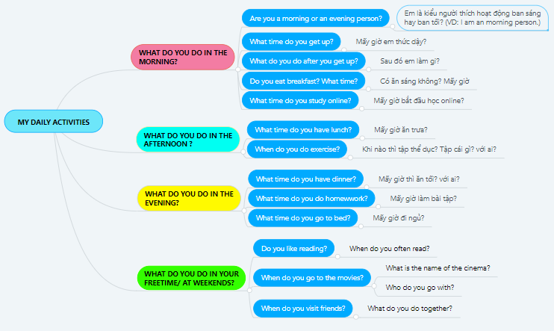

**CHÚ Ý:**

**AT + GIỜ**

**IN THE MORNING (buổi sáng/ chiều)**

**ON MONDAY/ SUNDAY/ WEEKENDS (ngày)**

**IN MY FREE TIME**

**II. Further discussion (Câu hỏi thảo luận cuối kỳ):**

• Are you a morning or an evening person?(bạn là người buổi gì)  I am a morning person

• What time do you get up?(bạn dậy lúc mấy giờ)  I wake up at 6 o'clock

• What do you do right after you get up(lúc mới dậy bạn làm gì) (brush my teeth, wash my face, take a shower...) I wash my face

• When do you do exercise? I don’t exercise.

• Do you eat breakfast? Do you do exercise? I don’t breakfast, t don’t exercise.

• What time do you go to school? I go to school at 7 pm.

• What time do you have lunch? I have lunch at 1 pm.

• What time do you go to bed? I go to bed at 9 pm

• What do you often do in your free time? In my free time. T read book.I play games and listen to music.

• Do you like reading? Yes

• When do you often read? I often read in my free time.

• When do you go to the movies? I go to the movies on the weekend

• When do you visit friends? I visit friends on weekend

• …